HW #4 Interpolation

Name: Jian Wang Fsuid: Jw09r

- Executive Summary

Generate the function of yield rate via the given eight points under the natural cubic spline algorithm and plot the yield curve and forward rate curve for twenty years. Besides, using the existed spline curve to get the yield, discount factor and forward rate for seven years.

I. Statement of Problem

Using the natural cubic spline algorithm to generate the yield curve and the forward rate curve under the eight given yield points. Our main tasks are as follows:
- Implement the cubic spline algorithm. Test your implementation and show that it is working correctly.
- Use a natural cubic spline to plot the yield and plot the yield curve for twenty years.
- Use the natural cubic spline to compute and plot the forward rate curve over twenty years
- What is the yield, discount factor and forward rate for seven years?

II. Description of the Mathematics
Natural cubic spline requires following condition:
On each interval [], [],…, [] , S(x) is given by a different cubic polynomial, and we
have the same first derivative and second derivative at knot point from two sides.

Since is a cubic polynomial on , is a linear function satisfying and and therefore is given by the straight line between and :
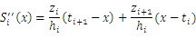
Where , if this is integrated twice, then the result is

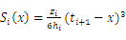+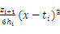+(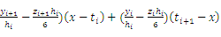
Where:
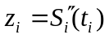
The linear system for with and is symmetric, tridiagonal, diagonally dominant, and of the form
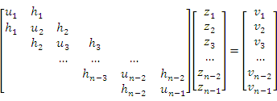
Where
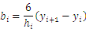

Calculated using the algorithm:
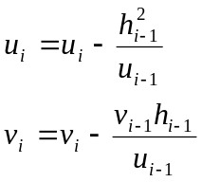
We can get 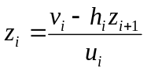
Then we can get the as follows:

Where

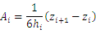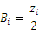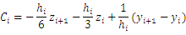

After we get the yield curve, from the formula given by the problem, we can get the value of forward rate f and discount factor D as follows:

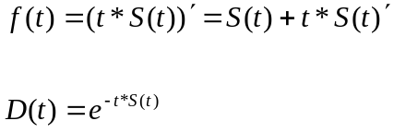
III. Description of the Algorithm

The algorithm is as the follows:

/
End do
Zn=0
For i= n-1 to 1 step -1 do
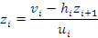
End do
Output (

IV. Results

With the help of software VBA, I got the result as follows:

V. Conclusions
From the interpolation, we get the continuous function which goes through the given knot points and smooth. In order to get the curve image, I choose 1000 points from 0.5 to 20 with constant interval, compute these values with the interpolated continuous function and line up these points in gnuplot.
Then use the same method to different functions: , to acquire these other two curves.
VI. Code Listing

<cubic.h>
#ifndef CUBIC_H
#define CUBIC_H

class Cubic
{
public:
Cubic (int m, double xseris[], double yseris[]);
double getvalue ( double m);
double getfirstderivative ( double m);

private:
int knot_number;
double* t;
double* y;
double* C;
double* D;
double* z;
};
#endif;

<cubic.cpp>
#include "cubic.h"
#include <iostream>
#include <iomanip>
#include <math.h>
#include <fstream>

using namespace std;

Cubic::Cubic(int m, double xseris[], double yseris[])
{
knot_number=m;
t=xseris;
y=yseris;
C=new double[m];
D=new double[m];
z=new double[m];
double* h=new double[m];
double* u=new double[m];
double* b=new double[m];
double* v=new double[m];

for (int i=0;i<=m-2;i++)
{
h[i]=t[i+1]-t[i];
b[i]=6*(y[i+1]-y[i])/h[i];
}

u[1]=2*(h[0]+h[1]);
v[1]=b[1]-b[0];

for (int i=2;i<=m-2;i++)
{
u[i]=2*(h[i]+h[i-1])-h[i-1]*h[i-1]/u[i-1];
v[i]=b[i]-b[i-1]-h[i-1]*v[i-1]/u[i-1];
}

z[m-1]=0;

for (int i=m-2;i>=1;i--)
{
z[i]=(v[i]-h[i]*z[i+1])/u[i];
}

z[0]=0;

for (int i=0; i<m-1;i++)
{
C[i]=(y[i+1]-z[i+1]*h[i]*h[i]/6)/h[i];
D[i]=(y[i]-z[i]*h[i]*h[i]/6)/h[i];
}

delete [] h;
delete [] u;
delete [] b;
delete [] v;

}
double Cubic::getvalue(double m)
{

for (int i=0;i<=(this->knot_number)-2;i++)
{
if ((m>=(this->t)[i])&&(m<=(this->t)[i+1]))
{
return z[i]*pow((t[i+1]-m),3)/6/(t[i+1]-t[i])+z[i+1]*pow((m-t[i]),3)/6/(t[i+1]-t[i])+C[i]*(m-t[i])+D[i]*(t[i+1]-m);
}
}

}

double Cubic::getfirstderivative(double m)
{
for (int i=0;i<=knot_number-2;i++)
{

if ((m>=(this->t)[i])&&(m<=(this->t)[i+1]))
{
return (-1.0/2)*z[i]*(t[i+1]-m)*(t[i+1]-m)/(t[i+1]-t[i])+(1.0/2)*z[i+1]*(m-t[i])*(m-t[i])/(t[i+1]-t[i])+C[i]-D[i];
}
}

}

<main.cpp>
#include "cubic.h"
#include <iostream>
#define _USE_MATH_DEFINES
#include <math.h>
#include <float.h>
#include <fstream>
using namespace std;

int main()
{

double t[8]={0.5,1,2,4,5,10,15,20};
double y[8]={0.0552,0.060,0.0682,0.0801,0.0843,0.0931,0.0912,0.0857};

Cubic a(8,t,y);

ofstream out;

out.open("output.txt");

for (int i=1;i<=7;i++)
{
out<<a.getvalue(i)<<' ';
}
out<<endl;
for (int i=1;i<=7;i++)
{
out<<a.getvalue(i)+i*a.getfirstderivative(i)<<' ';
}
out<<endl;
for (int i=1;i<=7;i++)
{
out<<pow(M_E,(-1)*i*a.getvalue(i))<<' ';
}
out<<endl;
out.close();

out.open("yield curve.txt");
{
for (int i=0;i<1000;i++)
{
out<<0.5+(20-0.5)/1000*i<<' '<<a.getvalue(0.5+(20-0.5)/1000*i)<<endl;
}
}
out.close();

out.open("yield curve original.txt");
{
for (int i=0;i<=7;i++)
{
out<<t[i]<<' '<<y[i]<<endl;
}
}
out.close();

out.open("forward rate curve.txt");
{
for (int i=0;i<1000;i++)
{
out<<0.5+(20-0.5)/1000*i<<' '<<a.getvalue(0.5+(20-0.5)/1000*i)+(0.5+(20-0.5)/1000*i)*a.getfirstderivative(0.5+(20-0.5)/1000*i)<<endl;
}
}
out.close();

out.open("forward rate curve original.txt");
{
for (int i=0;i<7;i++)
{
out<<t[i]<<' '<<a.getvalue(t[i])+t[i]*a.getfirstderivative(t[i])<<endl;
}
}
out.close();

out.open("discount rate curve.txt");
{
for (int i=0;i<1000;i++)
{
out<<0.5+(20-0.5)/1000*i<<' '<<pow(M_E,(-1)*(0.5+(20-0.5)/1000*i)*a.getvalue(0.5+(20-0.5)/1000*i))<<endl;
}
}
out.close();

out.open("discount rate curve original.txt");
{
for (int i=0;i<7;i++)
{
out<<t[i]<<' '<<pow(M_E,(-1)*t[i]*a.getvalue(t[i]))<<endl;
}
}

return 0;
}

